**W12 mini assignment**

**Student ID: 490111165 Student Name: Jialu He**

**Contribution for demo – E-textbook part**

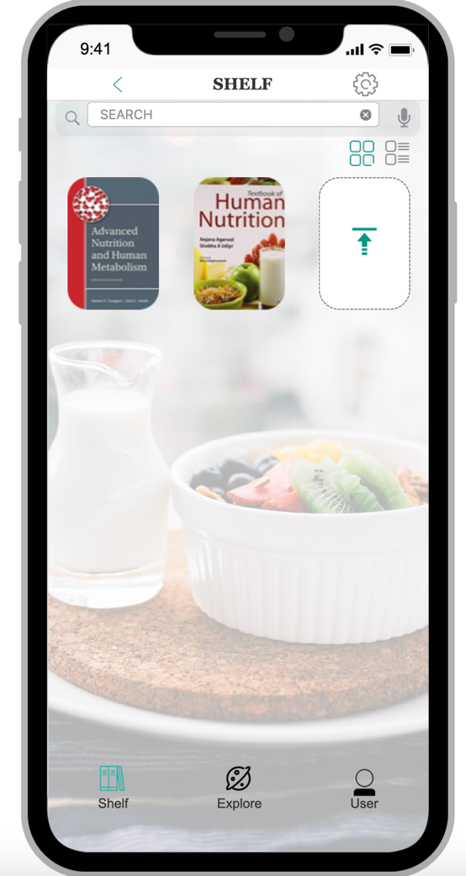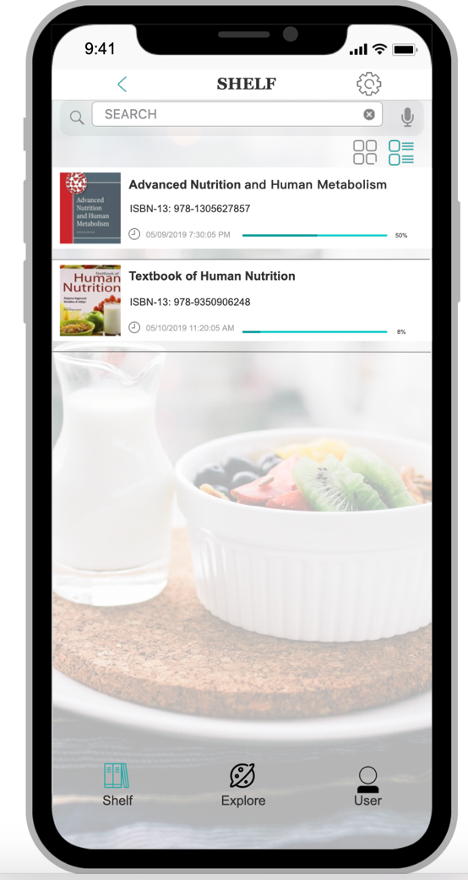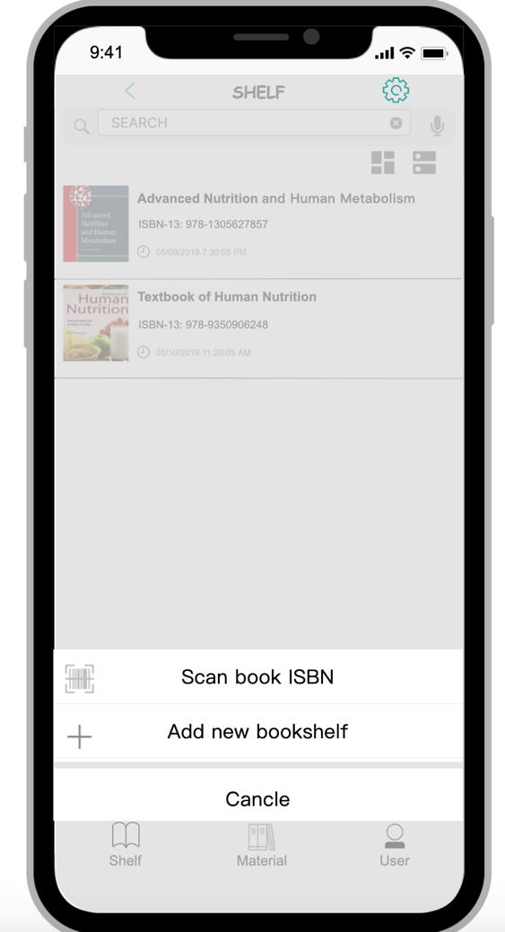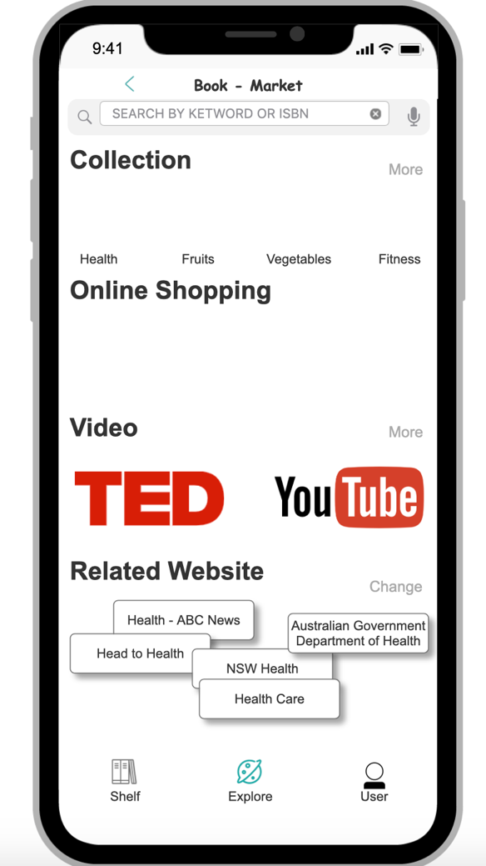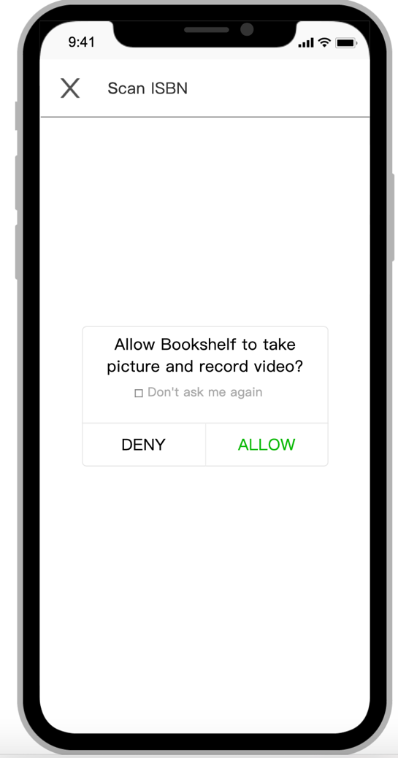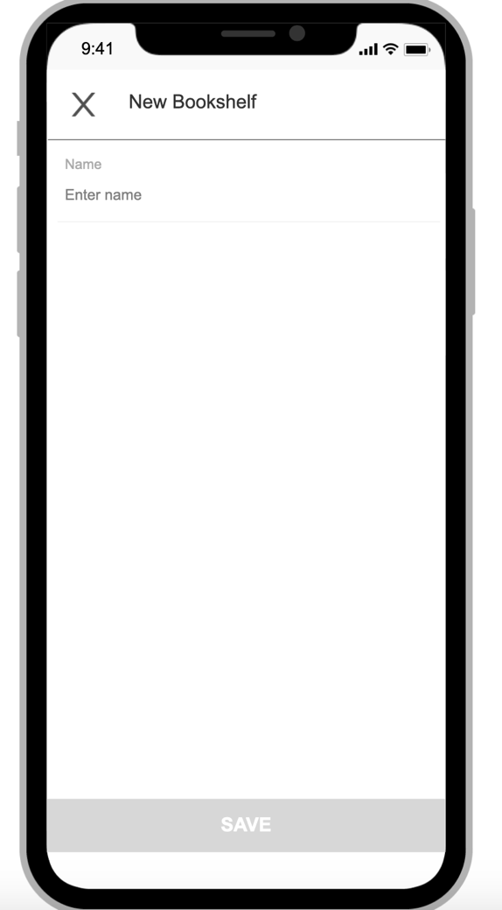

The main work for this week is demo design. I focused on “E-book function and “Deep learning” function.

1. For **the book shelf,** I design two version to see it, one is a normal version and the other one shows some detailed information about “book name”, ”ISBN” and “Last Reading time”. Users can track their reading process in the second version.
2. For **Setting**, I design 2 functions, but it will stop into the current page (It will need to link more webpage, so I stop it). Future, people can use it to scan the book ISBN and add new book into shelf.
3. For **Explore page**, the main purpose of this page is “deep learning”. Users can get more information via this page (video, new book, related website). However, I don’t link more webpage.
4. For **E-Book** part, I correct all page’s layout and make sure every page has same position and size button, as well as the word position and size.

Overall, I did the contribution for **Concrete task: 7.2** “Suppose you want to get more information, like video or buying books, show me what you want to do” And **Concrete task: 8.1 “**Suppose you want to see the different layout about the shelf and check your reading process, show me what are you going to do”.

**Contribution for report – think-aloud and the final layout of the document**

**Slides 1-6, 17, 40-49, 73-76, 94, 120-131**

slides 5 and 6 - prescribed tasks and additional tasks

slides 17 – make the table and set the questions

slides 40 and 49 - think-aloud - performance data / SEQ / UMUX-Lite / Simple Open Question / Qualitative Observation / Strengths and problems of interface / think-aloud progress questions

slides 73 - 76 CW details

slide 94 - user observations

slides 120-131 think-aloud for mini-assignment11

**Co-ordination roles: Update Trello and provide sample for Trello**

**Check all content’s grammar.**

**The final layout of the document and coversheet.**